Gabriela Hernandez

Mari Kawasaki

Mia Russell

Monse Sepulveda

**Negative Impacts of Gang Injunctions: Vasquez v. Rackauckas**

**Abstract**

*In this research, we confront studies that have argued for the effectiveness of gang injunction by providing an analysis of the ways in which gang injunctions have and continue to violate the civil rights of people served as well as community members. We explore the case study of the OVC gang injunction in the City of Orange and their successful on-going litigation against the District Attorney’s decision to serve the injunction to the gang as an unincorporated association. Finally, we analyze current opting out procedures, highlighting that their existence demonstrates little beyond the fact that court decisions have changed the way gang injunctions are managed. These opting out procedures have proven largely ineffective and difficult to pursue.*

**Introduction**

*I feel that police officers, not all, but the majority, have this mentality where they believe that the only way of fixing a problem is shoving it under the rug and putting us in prison. But what they forget is that people don’t stay there forever and they come out worse, it’s crazy. They claim that [gang injunctions don’t] violate our civil rights. They tell us what we can or cannot do, what time we have to be inside our homes. How is that not violating civil rights? It’s like putting a wall around the neighborhood, like a prison. They tell us what we can wear, what we can’t wear, what we can do, what we can’t do, we can’t be inside our homes without being seen from outside. I know they think it’s not violating our rights but have you seen the list of rules that they have? When has restricting the clothes you wear not been a violation of your civil rights?*

*Gil, a City of Orange Resident*

In recent decades, governmental and non-governmental organizations have asserted that the problem of gang violence has proliferated across the nation, in urban and rural areas, as gangs “fight for territorial control and market dominance” (Crawford 2009, 161). In fact, “some estimates place gangs as being responsible for 10% of all crime nationally [and] in gang-impacted neighborhoods, gang crimes can represent one-third of all violent crimes and one half of all serious violent crimes” (O’Deane and Morreale 2011, 2). In California, there are an estimated 300,000 gang members in over 6,100 different street gangs (O’Deane and Morreale 2011, 3).

In response, state governments have imposed civil gang injunctions. The first injunction zone in California was established 1987 in Los Angeles, and the “legislature officially authorized the use of civil injunctions to control gang violence in 1998” (Crawford 2009, 162) through the California S.T.E.P. Act (Appendix IV). Research on the effectiveness of gang injunctions has argued that “gang injunctions have a clearly demonstrable positive effect on some neighborhoods; some have even had a remarkable impact” (O’Deane and Morreale 2011, 5). In 2002, Jeffrey Grogger conducted research on gang injunctions’ effectiveness in Los Angeles, and argued that after a year violent crimes had decreased by 5 to 10%. In 2005, Maxson et al contended that injunction areas experience positive short-term effects including decreased gang presence, fewer reports of gang intimidation, and less fear of confrontation with gang members. In 2011, O’Dean and Morreale found that in California gang injunctions, “calls [for violent crimes] decreased 11.6%, [and for less serious crimes] calls decreased 15.9%” (1) seemingly confirming previous findings.

However, the data interpretations of these studies are questionable. For instance, O’Dean and Morreale interpret the reduction of service calls as evidence for reduced crime in gang injunctions zones. We address the possibility that people within these communities face the same level of crime but have chosen not to call police due to concerns that the police coming into their homes might result in being put on the gang injunction list. Also, these studies have tended to ignore the racial, economic and class dynamics at play in the implementation of gang injunctions. In this paper, we provide a review of research addressing this gap. We argue that, not only do gang injunctions have profound negative impacts on the civil rights of the communities and individuals placed on the list (Jones 2008; Barajas 2007; Caldwell, 2010; Hughes 2006; Stewart 1998; Wang 2008; Werdegar 1999), but these policies also lack an effective opting-out procedure, resulting in many individuals being on the list for decades (Crawford 2009). Additionally, the Orange County District Attorney’s (OCDA’s) failure to provide clear evidence identifying those in the list as gang members, is a breach of their constitutional and citizenship rights. This raises the question of the power of the state in designating individuals or groups as criminal organizations in violation of due process. Throughout this paper, the personal experience of Gil, an Old Town Orange resident, illustrates our argument, the ways in which citizens under gang injunctions must continually contend with abridgments of their civil rights, and the actions of community organizations that have recently begun to legally challenge gang injunctions.

This research was motivated by specific questions raised by Chican@sUnidos, a Santa Ana grassroots organization, about the effectiveness of gang injunctions. First, we deal with issues regarding the constitutionality of gang injunctions, their impact on the community, racial prejudice in these policies, and their effectiveness. Second, we explore the gang injunction in Old Town Orange against the Orange Varrio Cypress gang. In this case, dozens of people in the list challenged the DA’s decision and a U.S. District Court ruled in their favor. Finally, we deal with the gang injunction Petition for Removal procedure, and present our struggle to obtain the current forms, which illustrates why individuals might have been unable to opt out. This is intended to provide basic information and resources for individuals interested in pursuing legal action against gang injunctions.

**Civil Rights and the Effectiveness of Gang Injunctions**

In areas deemed “urban war zones,” the courts have utilized “public nuisance injunctions as a means to control street gangs” (Atkinson 1694, 2006). “[T]he ability of courts to interfere [with public nuisances] by injunction is one recognized from ancient times and by indubitable authority;” however, the courts must first provide evidence supporting the existence of a nuisance as defined by law (Atkinson 1698, 2006). After the court recognizes a nuisance, a city may proceed with the implementation of a civil gang injunction with the intent of protecting the community from gangs and their activities. Assistant DA John Anderson suggests that the civil rights of one group may, and perhaps should be, violated for the sake of the greater community when he summarizes the issue as “a weighing and balancing of the rights of the community to the peace and comfort and enjoyment and safety of the community vs. the rights of association,” in which the association (and presumed members of the association) is perceived as a “nuisance” external to the community they are a part of (OC Weekly May 28, 2009). However, too often gang injunctions obstruct the individual civil rights of people in its crusade to protect a community. The gang injunction against Orange Varrio Cypress exemplifies this.

Orange Varrio Cypress (OVC) is a Chicano gang based out of Orange's historic Cypress Street barrio established in the 1970s (Orange Gang Cops*,* 2009). The barrio, bounded by Walnut Avenue, Palm Avenue, and Glassell Street was firmly established by 1920. Residents that settled there came primarily from central plateau states of Mexico including Jalisco, Michoacan, and Zacatecas. Most came for work or to join family and friends that had emigrated to the area, escaping the harsh conditions in Mexico that followed the Mexican Revolution of 1910. The barrio was bound by a strong sense of community between residents and families and defined by commerce in the North Cypress Street area, which helped provide employment and services to residents, as well as the citrus industry. Men worked picking oranges in the groves and women worked in packing houses. Area activities included picnics, clubs, religious holidays, school events, street fairs, various classes and community programs (*Cypress Street Barrio*).

In February 2009, the OCDA and City of Orange Police Department (OPD) filed a civil gang injunction against 115 assumed members, allegedly among the “most active participants,” of the OVC gang (ACLU May 14, 2009). DA Rackauckas accused the OVC members of attempted murder, assault with a deadly weapon, terrorist threats, robbery, and drug sales as rationale for the injunction (ACLU May 14, 2009). The “safety zone,” 16 percent of the city of Orange, covered a 3.78-square mile area centered on the historic Cypress Street barrio. Included in the zone are Orange’s historic downtown, City Hall, a public library, Chapman University, and a large hospital. This entire zone is a predominantly Latino neighborhood.

Gil’s was one of many names on the original list of the OVC gang injunction. He has lived in the OVC area for the past 20 years and at the age of thirteen was put on a list of local gang members by police:

I was walking down the street near this park behind my house with a friend of mine, when two undercover gang unit officers approached me but they approached me in a violent way. They didn’t identify themselves as cops, I didn’t see a badge, they were in an unmarked car, they were dressed in a black shirt with jeans. When they approached me, they approached me in a provocative way, like trying to get a response from me. Luckily, one of their shirts rolled up and I see their badge, and I was like, “oh, that’s a cop”. And then that’s when they pulled me over, they sat me down.

The two officers presented Gil with a S.T.E.P. card. Then, he was intimidated into signing it:

What they would do was trick people into signing [it]. They would tell you, “oh, we are just presenting this to you because this is a known gang area and we just want you to know that, so we need you to sign this so you know this is a gang area”. But really what they would do was get you to sign that, which is pretty much admitting to the gang and they would later on use them against you in court. [...] They made me believe that if I didn’t sign it, I was gonna go to jail so they pretty much tricked and intimidated me.

The S.T.E.P. card was later used against him when, almost ten years later, he was served the gang injunction notice. Gil discovered he had been included in the gang injunction when the police burst into his home one night:

They went to every person’s house that was on the list. An injunction is like a civil matter, which means that when they come they should be like serving you but they came here like they were doing a raid, with the DA and a bunch of police officers. I thought I was being raided.

Police gang units and the DA’s office have said that they serve the lawsuits in this way, similar to a drug bust or a SWAT raid, because the defendants have been determined “active, potentially violent, criminal gang members,” the goal therefore being “to surprise them with the suit, lest they plan any retaliatory attacks, skip town or, worse, reach for a weapon” (OC Weekly May 28, 2009).

As the police left Gil’s home, they handed him a packet. By law, “prosecutors must serve each defendant with a copy of the complaint in order to include them in a lawsuit” (Grogger 73, 2002). This packet included a list and photographs of the accused and the crimes that placed them on the list. According to him:

The majority of the complaints that they allegedly received from old town residents were complaints that could be received about anybody, like drunk in public. I know who really is part of the gang in this neighborhood and who isn’t, and I can honestly say that there were many innocent people who were on that list, that were not gang members in any way. So, when you see that, when this is supposed to be a gang injunction, and you see innocent names on there, what does that tell you?

Additionally, the packet included information on the civil injunction served against him as a gang member, the activities and items he was no longer allowed to do or possess within public view, and opting out forms.

Gang injunctions prohibit defendants from a “mix of activities already forbidden by the law, such as selling drugs or committing vandalism, and otherwise legal activities, such as carrying a cell phone or associating in public view with other gang members named in the suit” (Grogger 72, 2002). Contrary to popular belief, the constitution has not been interpreted to include “‘generalized right of social association’” (Atkinson 1703, 2006). Rather, protected associations “fall into two categories: intimate associations and associational interests that are instrumental to religious and politically expressive activity” (Atkinson 1703, 2006). The first, intimate associations, includes “fundamental relationships includ[ing] marriage, the begetting and bearing of children, child rearing and education, and cohabitation with one’s relatives” (Atkinson 2006, 1710). These relationships are “instrumental associations [through] which people associate ‘in pursuit of a wide variety of political, social, economic, educational, religious, and cultural ends’ that are protected by the First Amendment” (Atkinson 1703, 2006).

Nevertheless, gang injunctions prevent those on the list from associating with one another in public. To justify the inclusion of non-gang members, the DA claimed the defendants were guilty by association due to family relations or friendship with other alleged members. Consequently, people were afraid to visit relatives, “affect[ing] people’s daily associations with family members and restrict[ing] public association for any reason, including political purposes, supports the proposition that… gang injunctions limit associations protected by the First Amendment” (Caldwell 271, 2010). ACLU of Southern California staff attorney Belinda EscobosaHelzer points out that this wide net, sweeping approach to the injunction is a threat as it “ensnares innocent victims and threatens to take away their most basic freedoms – associating with family and friends” (ACLU May 7, 2009). Gil spoke of the impact on people in his community:

There were people in the gang injunctions that were relatives, mothers, sons, brothers, sisters, so they couldn’t be outside together. They couldn’t be seen together because they could be arrested.

District Court Judge Valerie Baker Fairbank also noted an example of the injunction’s effects on families in her ruling on the OVC case:

When the grandfather of one set of [of brothers] had a stroke and was taken to a hospital in the Safety Zone in the middle of the night, their mother was forced to decide whether to permit the brothers to visit the publicly accessible hospital, an act that would violate both the curfew and association provisions of the Order (Witness LA May 11, 2011).

Gang injunctions have impacted families and personal relationships in other zones as well. In 2007, Antonio Buitrago, a 23-year-old Latino, and his cousin Antonio Garcia were served an injunction in San Francisco. They consider each other brothers and share the interrelated nicknames “Fat Tone” and “Little Tone” (Jones 2008, 57). Yet, because the gang injunction “alleged that both he and his cousin [...] were gang members” they have been enjoined “from meeting together in public” (Jones 2008, 45). As stipulated in the injunction, “if Mr. Buitrago were to leave from school, cross the street into his neighborhood, and see his cousin, he would have to cross back over to the other side of the street, or pass by his cousin and act as though they were strangers. If Mr. Butriago were to stop and talk to his cousin in public, he could be prosecuted and end up spending up to six months in county jail” (Jones 2008, 45-46). Although courts have determined that civil injunctions protect legitimate state interests and do not unjustly inhibit the rights of those served, most injunctions “so greatly impacts [sic] so many gang members’ fundamental rights of association with family [it cannot be] ‘narrowly drawn to express only the legitimate state interests at stake’” (Atkinson 1713, 2006). Also, by inhibiting the association of family, gang injunctions become detrimental to the purpose they are meant to achieve, the security of the community, since “family connections play an important role in preventing gang activity and in leaving gang activity behind” (Caldwell 289, 2010).

Furthermore, previous court cases determined that because “gang members were not engaging in protected politically expressive or religious activity […] they did not deserve instrumental associational protection” (Atkinson 1703, 2006). However, the ACLU has demonstrated that by denying legal activities, gang injunctions restrict intimate association and the pursuit of social, educational, and cultural ends:

Render[ing] ‘[T]he local pizza parlor off limits when taking the Little League team out after a game. There is no exception for attending a family wedding or college graduation party at a community center, or just a simple Fourth of July barbecue in the park. Attendance at occasions that others take for granted is simply forbidden as long as any alcohol is present or if, as noted above, a cousin, brother, sister, aunt or uncle has also been served with the injunction and may be in attendance’ (Caldwell 277, 2010).

By limiting these instrumental associations, gang injunctions deny those identified in the injunction their rights to “petition to government, to worship, and to stand in line together while voting” based on the possibility of associating with one another in public (Atkinson 1717, 2006). In implementing stringent measures regarding these associations, the court fails to recognize that “mere public association is not harmful to the community itself; rather it is the destructive results that occur when gang members associate to engage in nuisance activity together” (Atkinson 2006, 1719).

Beyond public association, those named in the suit are unable to participate in other legal activities “such as being out after dark, possession of various objects, making gang-related hand signals, and wearing gang colors” (Atkinson 1694-5, 2006). The injunction criminalizes activities associated with daily life, such as going out in public after 10 p.m., associating with anyone in the injunction, and moving freely within their own neighborhood (ACLU May 7, 2009). Probation-like conditions are imposed without a court ever having ruled that they individuals should be subject to these conditions. Belinda EscobosaHelzer argues that people in the list “cannot engage in lawful daily activities or continue to live their lives and exercise their freedoms without risking arrest and incarceration for violations of this untested injunction” (ACLU Sep. 23, 2009). Gil experienced this as the City of Orange enforced the gang injunction:

I felt like a prisoner in my own home. I could no longer walk to the store, I would no longer stay on my porch, I couldn’t take my kids to the park, I couldn’t live my life.[...] Every time I stepped out there (points out to the street through the window), a police officer would go after you. I mean, these rules are unbelievable. There was one that said that I was not allowed to drink alcohol in public or *view* of the public. So that means that I can’t sit right here (points at his kitchen table) having a beer, and a cop sees me through the window, he could’ve definitely come inside my house and arrest me.[...] When you are placed in a gang injunction list or you are in a “safety zone”, [the police] can pull over whenever they feel like it. So, if I were to walk down the street, they could snatch me up, pull me over, search me, or take pictures of me without my consent. They do it all the time. They’ve gotten to the point where out in public they make me take my shirt off and take pictures of me.

Gil described the case of one man who was arrested for stepping outside of his house as it is next to a mural deemed related to gang activity:

There’s this mural in Cypress Street, well, this guy was standing right next to that mural and they arrested him for it. They said that the mural represented the gang but it doesn’t, it was a mural that a famous artist drew. And the man was arrested for it. The mural is, literally, right next to his house, like right outside it, and they arrested him for it.

In the OVC area, the sentence for violating any prohibition on the list is six months to one year in prison with a fine. Although many scholars have questioned the constitutionality of the prohibitions in gang injunctions, the recommendations of the court have at times been overlooked. Additionally, the scope of gang injunctions have expanded and “recent injunctions include different prohibitions that have not yet been addressed by higher courts, such as a restriction against riding a bike” creating more concern over the constitutionality of gang injunctions (Caldwell 2010, 273). More often than not, “gang injunctions are used by law enforcement as tools for harassing these youth” resulting in the community as a whole withdrawing from law enforcement (Caldwell 2010, 275). And, often create “unjust restrictions on the liberty of people who are not gang members, alienates communities, and promotes gang attachments” (Caldwell 2010, 289). These circumstances encourage movement in secret and push youth away from law enforcement and towards the open arms of gangs.

Gil has seen gang injunctions create distrust of the police within the OVC community:

I know a lot of youth here, when they see police officers, they feel the opposite of safety. Police officers pull people for nothing, they are constantly patrolling, constantly pulling people over. And these are youth, regular kids in a group hanging out in a group but the police *will* walk over to them. They first start with the youth, harassing them, the parents start catching on, so the whole neighborhood is backing away from the police officers.

This viewpoint contrasts from that espoused in an article by O’Deane and Morreale (2011) who, as mentioned above, argued that gang injunctions positively decrease crime levels as exhibited through a decrease in service calls made to police within injunction areas. The article also poses the question of why some communities take no action either for or against injunctions without providing an answer, failing to provide an intersectional analysis of factors like race, class, and ethnicity of the communities and a community perspective. Claiming that people make fewer complaints to the police, and therefore the injunctions effectively lessen crime, O’Deane and Morreale fail to consider the community sentiment towards the police in times of heightened tension such as when an injunction has been served.

When the injunction was served, Gil also remembers signs on every corner instructing people to call the police if they saw a gang member. The signs gave no instruction towards the identification of a gang member, allowing any person to be mistakenly identified. This is an example of a statute that “may be unconstitutionally vague either because it vests too much description in the hands of law enforcement or because it fails to give adequate notice to the public with regards to the nature of the activity that is proscribed” (Caldwell 2010, 283).

In addition, those under the injunction could not protest nor peacefully assemble as they could not be seen together without facing arrest. Miguel Bernal Lara, a 20-year-old college student, a plaintiff in the case, was among many who were enjoined but were too afraid to leave their home and participate in protests against the injunction at Orange City Hall, because of its location in the injunction area and for fear of being arrested for violating the terms of the injunction (ACLU Sep. 23, 2009). Gil himself could not be part of protests against the OVC gang injunction:

There were a lot of protests in the Orange circle, but a lot of people that protested were [...] just people in the neighborhood who didn’t want it. But us [people served the injunction], we couldn’t go because if we were seen together, we would automatically be sent back to jail. [The police] say that they don’t violate our constitutional rights, well, then why is it that we can’t protest? That’s the first amendment rights, freedom of speech, freedom of press, but we couldn’t do it because we would’ve been arrested.

In public, the police could pull them over at any time and search their person without a warrant or reasonable cause simply because they associated with those or themselves were on the list. As Gil correctly pointed out, this is a clear violation of the constitutional first amendment rights to free speech and the right to peaceably assemble (Atkinson 2006; Allan 2004; Barajas 2007; Caldwell 2010; Crawford 2009; Wang 2008; Werdegar 1999) but this has yet to be legally recognized in the courts.

Gil believes that despite the authorities’ insistence that Old Town Orange was in dire need of greater policing of the community and gang members, the community itself has never had much of a gang problem:

This neighborhood was not bad at all, they just make you think that. This neighborhood wasn’t ever really that bad.[1] The worse we had was the Chapman students running around naked twice a year. And the cops allow them to run around naked twice a year, which is indecent exposure, which is kind of against the law, and you guys are allowing it? Whatever. Every once in awhile you’ll hear a fist fight but it’s never been that bad.

Currently, the OVC gang injunction boundaries include Chapman University and over time the university has acquired more property within the surrounding neighborhood. The area has become increasingly gentrified as the university gains in prestige. Like others “in many communities, gang injunctions are perceived as a part of larger efforts to force low-income people of color to move out of gentrifying neighborhoods” (Caldwell 2010, 276). Gil mentioned areas like El Modena that have a larger gang problem but no gang injunction. However, the aim of forcing people to move out has not worked. Although Gil did consider moving to a neighborhood outside the injunction area, he did not have the financial means to do so.

**Vasquez v. Rackauckas**

Immediately after the injunction was served in February 2009, a collective voice of opposition rose up and held vigils, formed an “Orange County Youth Injunction Defense Committee,” protested the inclusion of a historic mural in the lawsuit (mentioned above by Gil), appeared on media programs, and petitioned through the California Courts Self Help Center website to have Judge Daniel Didier removed from the case because of his connection to the other 5 injunctions in the county (OC Weekly May 15, 2009). This group of people listed on the injunction, with the help of Yvonne Elizondo, wrote to ACLU to request their legal assistance (OC Weekly May 28, 2009). Of the 115 individuals under the injunction, 62 people, including Gil, went to state court to fight allegations of being gang members. As a result, the DA opted for dismissing the charges (ACLU May 31, 2011). This case marks one of the few times that individuals under a gang injunction, with the support of legal representation of organizations, successfully fought against the charge that they were gang members (ACLU May 14, 2009). It was also unprecedented that a DA would dismiss cases against the bulk of the alleged gang members under the injunction (OC Weekly May 15, 2009). This success also called into question other cases in which people were unconstitutionally subjected to injunctions yet had no resources to fight them.

Directly after the dismissal of the case, however, the OCDA signed the same injunction against the gang as an “unincorporated association,” rather than as individuals, but ultimately including the names of the individuals who had just been dismissed from the case (ACLU May 31, 2011). To do this, a gang must first be recognized as an unincorporated association. The determining factors of:

Unincorporated association asks whether the entity’s members (1) share a common purpose, and (2)(a) function under a common name (b) under circumstances where fairness requires that the group be recognized as a legal entity. Fairness requires recognition of the association when people interacting with it allege that their legal rights have been violated (Atkinson 1700, 2006).

A gang can be considered to share a common purpose, such as protection of a territory and function under a common name. However, gangs are not structured in such a way that a single person or officer can be designated to act on behalf of the whole. Whilst some of these factors can be questionable in relation to gangs, California law has time and again recognized gangs as a separate entity. Although “a gang is a legally distinct entity from its members, case law allows an injunction directed at an unincorporated association to be effective against its members nonetheless” (Atkinson 1701, 2006).

By serving injunctions to gangs as unincorporated associations, the city does not have to name individual defendants as the defendant is the gang as a separate entity.

Instead of placing it in individual people, like the first time they put us in the gang injunction list, they put individual names, but then they took us off and they hit us all as a whole, not as individuals. I guess to make it easier to put people in a gang injunction. But when they place people as a whole, I believe they can place anybody’s name that they want.

By serving the gang as an unincorporated association, the DA’s office was acting in the “LA approach” to the injunction, which assistant DA Anderson himself had criticized a year earlier: “In LA, they’ll sue the gang, and then they add people, not by going back to court, but simply by serving them. That’s a huge problem. They get the opportunity to object to their gang status only once they’re arrested for violating the injunction,” (OC Weekly May 28, 2009). This has happened in multiple gang injunctions since its application in Oxnard against the Colonia Chiques in 2006 (Atkinson 1696, 2006). Gil was also included in the 2009 “bait and switch,” which is how anti-injunction activists and lawyers describe the promise that certain individuals would be taken off of the list. He suspects that the bait and switch was a response to the OVC community’s fight against the gang injunction.

Yeah, I was one of those names where they did the “bait and switch” that the attorney had put us on. I believe that the only reason that they did that whole thing is because most people don’t fight the injunction. I believe they were not suspecting for us to fight back. Most neighborhoods don’t fight back, they just allow us. I believe they thought we were not gonna do anything about it. Before the injunction here, they had an injunction in East Orange and they just allowed the injunction to go through. But we fought it legally, we filled all our paperwork, we met with the ACLU, we met with a bunch of different lawyers and they took us off but they put us right back on.

In September 2009, the ACLU of Southern California filed a class-action lawsuit against OCDA Tony Rackauckas and the OPD. In 2010 the district court judge ruled against the injunction because, when the OCDA and the OPD served the gang as a unincoporated association, they violated the due process rights of the enjoined plaintiffs and thereby illegally placed them under a gang injunction. Once again, Gil was part of this legal case and he explained how it worked:

When they put us on the list, they named us as individuals, but when they put the injunction back in, they just put us all as a whole, that way we couldn’t fight it. [...] They didn’t give us a chance of fighting it. His [the DA] actions prevented us from defending ourselves in court.

“The Due Process Clause ‘at a minimum… require[s] that deprivation of life, liberty or property by adjudication be preceded by notice and opportunity for hearing appropriate to the nature of the case.’ The notice must reasonably convey the pendency of the action and it must afford a reasonable time for interested parties to make their appearance” (Atkinson 2006, 1724). As such, for an injunction to be constitutional, it must be determined “whether the notice given was ‘reasonably calculated under all the circumstances, to apprise interested parties of the pendency of the action and afford them an opportunity to present their objections’” (Atkinson 1724, 2006). However, in such an injunction served to an unincorporated association, “unnamed defendants receive no notice that the injunctions are being considered” and in “not naming individual gang members in or notifying them about the pending action, the government denies them their constitutional rights,” (Atkinson 1696 & 1725, 2006). In other words, “for those who [...] are served with a copy of the injunction after it is in place, there is no scheduled opportunity for the individual to challenge his or her inclusion in the injunction in court” (Caldwell 248, 2010). Similarly, in regards to due process rights, “enjoining only the gang as an entity, and then using the court’s broad equitable power to prohibit acts by all its members without giving them notice ex ante, is fundamentally unfair because it denies gang members a chance to contest the imposition of the injunction” (Atkinson 1731, 2006). For this reason, “suits brought against gangs as unincorporated associations [...] abridge unnamed gang members’ procedural due process rights” under the Constitution and Bill of Rights (Atkinson 1697, 2006). A gang injunction that has recently been introduced in Santa Barbara is planning on serving the gangs both as people and as an unincorporated association from the initial stages, taking a “whatever works” approach to enjoining the targeted “known gang members.”

Served a second packet, this time Gil and others were not given an opting out option as the law denies members of an unincorporated association the chance to contest the injunction (we discuss this at length below). Hector Villagra, director of ACLU/SC’s Orange County Office, points out that “none of the individuals represented in [the OVC] suit have had the opportunity to defend themselves before a judge, yet they are being treated like criminals. Nobody should have their liberty taken from them without the chance to present their case” (ACLU Sep. 23, 2009). The outrageous aspect of this gang injunction is that the deprivation of due process rights came directly from the District Attorney, which he did after learning that he needed to give the accused full due process rights, which he then circumnavigated by dismissing the first claims and reinstating them in a slightly different way.

Important in this discussion about the OCDA’s claim that the individuals served were gang members, was the creation of objective criteria with which to determine the identification of affected individuals. As numerous instances of police brutality in Orange County proves, without such uniform criteria there is “a risk of erroneous identification by police” (Atkinson 1728, 2006). Peter Bibring, an attorney with the ACLU of Southern California, likewise points out that the personal discretion given to the police in deciding who is in a gang “invites abuse and racial profiling” (ACLU May 7, 2009), especially as gang injunctions are used “almost exclusively against African-American and Latino youth (Caldwell 281, 2010). Erika Aranda is an example of an individual who was linked to gang membership on the basis of three minor incidents, none of which were related to gang activity. She was charged with trespassing for walking through an abandoned building to take a shortcut on her way to school, for attending a street fair with childhood friends, and for being present in her own home while her uncle was there, another alleged gang member. As a result of this, she was served a search warrant (ACLU May 7, 2009).

Within the OVC case, because “*clear and convincing* evidence ” has not been provided, racial profiling and harassment abound, and errors by the police and government opportunities were created for the ACLU to argue on behalf of those under the OVC injunction. Gil himself has seen the way in which police have imposed the gang injunction in discriminatory ways:

The way I see it, if you have a tan, you get pulled over. [...] I’ve watched Chapman students wreak havoc in this neighborhood and I never see one get pulled over. But a Hispanic kid? This happened to me, I walk down the street, to the store down the street, and I had five or six cops around me. I asked why they were detaining me and they said I was in a high crime area. Well, so is that Chapman student right there, so is that guy, so is that guy, so why? Why me? It’s almost like racial profiling. I feel that this is their way of kicking the Hispanic community out of this neighborhood because Chapman is buying things left and right. [...] They are kicking out the Hispanic community.

In addition, some of the people who challenged the OVC injunction have constantly been targets of police harassment, as Gil who recalls that while the case was being debated, the cops would often degrade and make fun of those under the injunction:

I remember during our court proceeding, they would stop people on the list, they would degrade us, they would make fun of us, they would tell us, “you are stupid if you think you are gonna win”. They would pull you over just to degrade you. These are police officers who would stop people over in the list just to degrade them.

In spite all of these challenges, Gil explained that, in his opinion part of the reason people in the OVC area fought against the injunction in comparison to areas like East Orange is most likely related to the fact that many of the people in the OVC area grew up in the area, are people of profession, and know their rights as citizens of the US.

I think that here we were able to fight it because there was people who grew up in this neighborhood who have professions, that became involved in politics, involved with the whole scene of that. In the other side, on the East side, the majority of the people over there are fresh immigrants that don’t know their rights, that are ignorant to the way the constitution is here. When you go to Mexico, a cop’s word is law and you cannot fight it. Not like here where you can file a complaint against a police officer. There, you file a complaint and they will come back to beat you up. So people who come from Mexico, who are new immigrants, still have that mentality. They don’t know that a police officer is doing a public service. We pay their wages. They think that they are the law.

Elizondo likewise pointed out that Barrio Cypress is home to second, third, fourth generation Mexican-American families who have been in the area since early 20th century and know their constitutional rights (OC Weekly May 28, 2009). In comparison, the gang injunction area in East Orange is mostly comprised of Mexican immigrants and first generation Americans whose knowledge of their civil rights are limited and believe that the words of law enforcement are law and undisputable rather than understanding the police to be public servants. An additional possibility to the lack of fight against the injunctions has to do with “the low-income communities... without financial resources” that injunctions are implemented in (Caldwell 280, 2010). As a result, those under the injunction are often undereducated in their rights and do not have the luxury of an attorney as it might “present an impossible financial burden” (Atkinson 1729, 2006). All of these considerations could provide individuals or organizations interested in fighting gang injunctions with an explanation for why the OVC movement was successfuland the type of support that other communities may require to achieve their goals.

**Court of Appeals challenge against the OVC gang injunction**

On May 10, 2011, the federal district court, agreeing with the ACLU, ruled that the OCDA and OPD had indeed violated the plaintiffs’ due process rights guaranteed by the Fourteenth Amendment by denying hearings to the alleged gang members, and ordered the police and prosecutors not to enforce the injunction against the plaintiffs (ACLU May 31, 2011). Unsurprisingly, the assistant DA, John Anderson, disagreed with the court ruling saying it “completely rewrites centuries of injunction law,” and that the county considered the issue a matter of state rather than federal law (Los Angeles Times May 11, 2011). However, this statement ignores the “doctrine of incorporation” within the Fourteenth Amendment of the United States Constitution, which binds the states to upholding the Bill of Rights when it declares that:

No state shall make or enforce any law which shall abridge the privileges or immunities of citizens of the United States; nor shall any state deprive any person of life, liberty, or property, without due process of law; nor deny to any person within its jurisdiction the equal protection of the laws.

The statement of the DA’s assistant raises concerns about the extent to which the DA’s office is abiding by its duty to work within the framework of Constitutional law.

The OVC case is a prime example that “in principle an injunction could be reversed at trial” and gives hope to future attempts to challenge gang injunctions (Grogger 74, 2002). Joseph Ybarra of Munger, Tolles& Olson, LLP, the law firm that jointly tried the *Vasquez v. Rackauckas* case, commented that the federal district court’s ruling “reaffirms one of the bedrock principles of our system and our society--that before an individual’s liberty is taken or restricted, the individual has a right to a hearing before a neutral decision-maker,” (ACLU May 11, 2011). In addition to its role in the case of those affected under the OVC injunction, *Vasquez v. Rackauckas* could hold great importance on a much larger scale. In making its way to the Supreme Court, it has the ability to set an important legal precedent for future gang injunctions or others served with the same deprivation of due process rights. By arguing that there is something fundamentally unconstitutional in the procedural aspect of serving the OVC gang injunctions, the ACLU and others arguing on behalf of the plaintiffs in *Vasquez v. Rackauckas* are actually challenging gang injunctions across the board. If the Supreme Court declares the OVC injunction unconstitutional, the same could be argued for other current and prior injunctions. In pointing out that the ruling should “compel all municipalities to assess their anti-gang initiatives for constitutional compliance,” the ACLU of Southern California understands the value that this case has for defeating unconstitutionally served injunctions statewide and perhaps further (Los Angeles Times May 11, 2011).

Still, the majority of cases brought against cities on gang injunctions end in favor of the city. For the OVC case, the ACLU represented a few in court and “effectively represent[ed] by proxy the other members’ interests in opposing the injunction” (Atkinson 1731, 2006). As a result of their effort, in 2012, it was decided that the OVC gang injunction could not be enforced upon the names placed on the original list due to a violation of due process rights. As such, it is not the case that there isn’t a gang injunction, but rather that the people on the original list, which included all those associated with gangs, cannot again be placed on the list. Thus creating a gang injunction enforced upon no one. Gil commented:

When they ruled in our favor, [the court] said they cannot enforce a gang injunction on the people in the original list. So there might be a gang injunction here but they can’t put anybody on it. Everybody that they wanted to put in the list, we were all ruled in favor. So they can’t enforce it on anybody. They can’t enforce it on me, they can’t enforce it on a lot of people.

The OCDA appealed this decision on May 16, 2012 and the OPD appealed it on May 31. Anderson called the decision “ripe for appeal,” and it is currently being taken to the 9th circuit court of appeals. About the court’s ruling, Gil commented that:

Ever since the ruling came out in 2012, a ruling came in that everybody was in that original list, the injunction was not to be enforced on them cause our rights to due process were violated. So the DA appealed, so right now we are back at Supreme Court.

Anderson also said that “no other group is afforded the same constitutional protections that the court in *Vasquez* has found to exist for criminal street members,” and acknowledged that the cost of further litigation will be worth it because gang injunctions have been “remarkably effective” in decreasing crime rates (OC Weekly June 23, 2011). These statements demonstrate that the DA’s office has failed to understand that regardless of what the effectiveness of the gang injunction may be, the implementation of the injunction violated the defendant’s right to due process.

**Removal from Gang Injunction Procedure**

The civil gang injunctions implemented in California have been in place for over thirty years. Yet a little noted fact in scholarship about injunctions is that most people initially placed under a gang injunction list remain so until this day. The California Assembly Committee on Public Safety recognized on July 5, 2011 that “existing law does not provide a time limit on the duration of gang injunctions as applied to an individual” (see Appendix IV). In other words, there are no stipulated statutes of limitations for gang injunctions. The only alternative for being removed from an injunction, the “opting out” procedure, has largely proven ineffective. Peter Bibring, an ACLU staff attorney commented that, “as a practical matter, [gang injunctions] are life sentences” (LA Times June 26, 2009). A study on California opting out procedures published in 2009 states that although individuals enjoined in a gang injunction “had always been able to petition the court for removal, this official process had not actually facilitated exit for gang members trying to find a way out of gang life” (Crawford 2009, 163).

When Gil was served the preliminary injunction in 2009, he did receive a Petition for Removal in the packet police gave him. He then used those forms to begin the process to file a petition for removal. However, the second time he was served, when included in the injunction as a group, there was no such form. Like Gil, many people served injunctions are not given information on how to opt out of an injunction, which has caused this process to be largely ineffective.

Statistics on the number of people who have been able to opt out reflect how ineffective the opting out procedure has been. In Los Angeles only in 2008 did the first person succeed in being removed from the gang injunction (LA Times October 10, 2008). In 2009, for the first time an individual enjoined in Orange County, specifically in San Juan Capistrano, was removed from the list (OC Weekly July 24, 2009). In the past few years, cities have started to aggressively challenge injunctions and a few have obtained court support. For instance, in Oxnard 81 defendants succeeded in being removed from the list in 2012. The OVC litigation described above has been one of the few successful challenges to gang injunctions in California. However, these are only three positive outcomes out of more than 150 gang injunctions statewide. In Los Angeles, where injunctions were implemented almost three decades ago, more than 11,000 people are still under gang injunctions.

These long-term gang injunctions create vast negative effects for enjoined individuals and the stories of thousands of residents shared in the media or in academic articles offer substantial documentation. California State Senator Roderick Wright commented that the injunctions have “hampered the ability of some young men to get jobs, because it is discovered when employers conduct background checks” (LA Times June 26, 2009). The Los Angeles Times published in 2009 the story of David, a 26-year-old Los Angeles resident who was served in 2001 because the police thought he was a gang member due to his associating with co-workers who were gang members. In 2002, he was arrested on a gun charge and, since then, he completely stopped associating with his co-workers both at work and in his personal life. Although, since his arrest he had not been convicted for over seven years, he had difficulty procuring employment because his name was associated with the injunction. “I’ve been clean, working every day, earning a living for my son”, he said, “I don’t think it’s fair that I am still in the injunction. It has kept me from getting a better job.” This type of experience highlights the importance of effective opting out procedures and the necessity of a statute of limitations for all gang injunctions.

In response to the fact that gang injunctions have persisted for decades with thousands enjoined, in 2009, the California state senate proposed modifications to injunctions that “would allow suspected gang members who do not commit a crime for five years to be automatically removed from civil injunctions unless prosecutors can show they remain a public threat” (LA Times, June 26, 2009). On July 5, 2011, the California Assembly Committee on Public Safety passed a bill that “creat[ed] a process whereby a person subject to a gang injunction can petition for injunctive relief if he or she meets certain criteria” (for the whole document, see Appendix IV). These criteria are:

1. The individual has not violated any provisions of the gang injunction.
2. The individual is not a member of a criminal street gang subject to the injunction, or a member of any other criminal street gang.
3. The individual does not have any pending criminal charges.
4. The individual has not been arrested within the past three years.
5. The individual has not obtained any gang-related tattoos within the past three years.
6. **The individual has not, within the past three years, knowingly been documented by law enforcement to have been in the company or association of another gang member known by the individual to be covered by the injunction, with the exception of an immediate family member.**
7. The individual is not acting, and agrees not to act, to promote or assist any activities prohibited by the injunction.

The passing of this bill, after more than three decades, stipulated the Statute of Limitations of Los Angeles gang injunctions (see Appendix IV). This, however, is still based on the discriminatory policies described above. First, it is based on the assumption that the individual served is guilty, forcing anyone seeking injunctive relief to prove their innocence, a legal maneuver unacceptable in any other area of the law. Second, that associating with gang members is a crime, even, as seen in David’s case, if associating is simply working with someone who is a gang member. Third, it criminalizes and stigmatizes the personal choices of citizens, such as the right to freedom of expression through tattoos or the wearing of certain clothing. Finally, it continues to force individuals who may have been acquaintances or close friends with those under the gang injunction to stop any form of communication, thus severing community and family ties.

Another crucial deterrent has been that individuals petitioning for removal are not appointed nor required access to legal representation. The right to legal representation “in criminal cases is guaranteed to a defendant, whereas in civil cases, one is provided with counsel only in special circumstances” (Jones 2008, 45). For this reason, most people who want to opt out must act as or procure their own representation. This, however, might prove to be immensely difficult for people who have no legal training and who must face highly trained attorneys. About this, Gil commented:

See, this is the beauty of a gang injunction. Since it’s a civil matter, you don’t have to be represented so ordinary people who have no legal training, no legal knowledge, are going up against DAs that have gone to law school and know all the loopholes. You either have the option to fight it yourself or you hire an attorney but an attorney won’t be appointed to you because it’s a civil matter, you are not being prosecuted. That’s where they get a lot of people because ordinary people are going up against lawyers who have no training at all, so they pretty much do what they want with you. People who don’t have the resources, are not financially stable to hire an attorney. Attorneys are very pricey, so the DA gets away with that.

Although Gil received substantial support from his community and the ACLU, most people who have received no legal training are left to fend for themselves in court, resulting in outrageously low numbers of people who have been able to opt out through the official process.

To understand why this process has proven so difficult, we set out to find the Orange County Petition for Removal forms. As initial research, we searched for these documents online and found that the OCDA office has a “Petition for Removal” available online (see Appendix I), meant to be used for anyone “who believes he or she was erroneously included in the lawsuit or injunction”. This 1-page statement provided very little information as it briefly explains who will precede the hearing (the OCDA’s office will hold a hearing to be presided over by a panel of two Senior Deputy District Attorneys not associated with the injunction action, and a representative from the Probation Department), states the right of the defendant to defend him/herself in court, assures that any findings will be kept confidential, and mentions the consequences if the defendant is found to be participating in any criminal street gangs after being removed from the list.

This document, the only one available online through the official website of the District Attorney, is outdated. It was used for gang injunctions implemented up to 2009 and has since been changed. To obtain the current and updated opt out forms, we sent letters to the City of Orange City Attorney and the DA’s office invoking the Public Records Act. City Attorney Wayne Winthers called back to inform us that his office does not have those forms and referred us to the OCDA. The DA’s office responded through a formal letter stating that, “based on the exemptions and exceptions listed above, the Office has no documents responsive to this request” (see Appendix V). Disagreeing with his claim, we requested these documents personally at the DA’s office in Santa Ana[2]. There we spoke with a staff of Deputy District Attorney Susan Eckermann’s office who immediately upon request provided us with a more recent copy of the new opt out process used in recent gang injunction, the “Petition for Removal - Informal Process” (see Appendix VI).

The Informal Petition for Removal process is an alternative to the “official” process and is begun when the defendant “notif[ies] the OCDA, [by] submit[ting] a written statement or statements detailing any information you want the OCDA to consider in making a decision whether to remove you from the injunction” and any information considered relevant may be included. Once the informal petition has been submitted, “the information you submit will be reviewed by a panel of Deputy District Attorneys, [and if they] determine that it is more likely than not [...] that you were never, or at present are not, an active participant in the named criminal street gang, the OCDS will remove you from the injunction and the terms of the injunction will not be enforced against you”. Similar to the outdated form available online, this document stipulated that if the defendant removed from the gang injunction is later found to be involved with criminal street gangs, the defendant will be re-served. However, this updated form expands the scope of what is considered as involvement in a street gang to “participating in criminal street gang behavior, such as claiming membership in a gang, associating with known active participants of a gang other than immediate family, being arrested for any gang-related felony or misdemeanor crime, or obtaining any gang-related tattoo”.

As explored at length above, it is this type of legal procedure that has allowed police abuse of power, the violation of individual’s rights, and racial discrimination. First, the broad scope of what “criminal gang behaviors” is defined as, leaves the process open for subjective and biased assessments of people’s lives. As an example of this, we recall Gil who was humiliated by the police when they made him take off his shirt in search of a “gang-related tattoo,” which brings up the question of what precisely is a “gang-related tattoo”. Although certain tattoos explicitly relate to specific gangs, others are merely personal preference or artistic expression of individuals, which may [and have] been considered as gang-related tattoos by the police. This criminalizes and stigmatizes a specific life style.

The “Informal Process” form we received was still not the one that the DA’s office uses currently. To specifically obtain that form, we contacted Deputy Attorney Susan Eckermann who is personally in charge of the gang injunction area within the DA’s office. Through her, and after weeks of research, phone calls and visits to the DA’s office, we were finally able to obtain a copy of the most recent opt out forms used by the DA’s office, which are the new standard for gang injunctions in Orange County (Appendix VII and VIII).

1. Affidavit and Motion - Request to be Removed from Gang Injunction

2. “Petition For Removal”

The petition for removal resembles the previous ones but clearly stipulates the differences and purposes of the “official” and “informal” processes, and includes a Spanish version of the document. The affidavit is a new addition to gang injunction opt out documentation, which defendants can use to begin the “official” process in court.

The process we went through to obtain this documentation (online research, letters to the DA, personal visits to the DA’s office, and phone calls to the Deputy Attorney) most pointedly demonstrates that these documents are not exempt from public disclosure as the OCDA claimed in his letter and that the DA’s office purposely stonewalled our request. Thus illustrating the difficulty individuals searching for these documents have when attempting to do so. This, we contend, has been a crucial deterrent for people in challenging gang injunctions.

An effective and simple way to give people greater access to these forms, and facilitate the opting out process, would be to have these forms available online through the DA’s website, emulating what cities such as San Francisco or Los Angeles have done. The website of the San Francisco City Attorney’s office contains a user-friendly package available through a clearly-marked tab and it is intended to be used by “persons living in the City of San Francisco who have been served with a Gang Injunction and who want the opportunity to demonstrate that they should not be restrained by the Gang Injunction because they are not active gang members” (see Appendix IV). This package contains: 1. Steps of the review and removal process, 2. Information regarding representation by counsel, 3. Instructions on submitting the petition, 4. Section regarding identifying information, 5. Section regarding information in support of petition, 6. Section for employment history, 7. Section for people who can provide support petition, 8. Section for additional information and petitioner’s signature, 9. Addendum regarding legal representation “to be completed and signed by your attorney.” The cities of Los Angeles, Oakland, and San Diego have similar packages available online, although slightly more difficult to find (see Appendix VI). These packages offer details on the procedure to petition for removal from the gang injunction, describe the review process, list eligibility requirements, and contain the form that must be submitted to the City Attorney.

The fact that these forms are available demonstrates that, to some extent, court rulings against gang injunctions and the pressure of organizations such as ACLU in the past few years have effectively limited the liberties taken by cities in California as they have implemented gang injunctions, as well as their understanding of their duty to respect and enforce due process. In 2008, the ACLU of Northern California successfully reached an agreement with the City Attorney’s Office of San Francisco and the Lawyers’ Committee for Civil Rights of the San Francisco Bay Area to establish administrative process for individuals to petition to opt out from gang injunctions. Now, as noted above the San Francisco City Attorney website has detailed information regarding the opting out process and opting out forms are easily accessible and readily available to the public. City Attorney Dennis Herrera has been quoted stating that “the opt-out process ‘both maximizes civil liberties protection for alleged gang members, and ensures the effectiveness of civil gang injunctions to protect San Francisco neighborhoods from violence and nuisance conduct” (*Gang Injunctions*). The OCDA office does not have the opting out forms for the OVC gang injunction readily available, hindering civil liberties protections for alleged gang members within the Orange County area. If gang injunctions are to be implemented, then the most recent and updated “Petition for Removal” forms, both formal and informal should be made easily available online through the OCDA’s website.

**Conclusion**

In this paper we have sought to demonstrate that, although certain studies have defended the effectiveness of gang injunctions, the experience of community members, academic research and a thorough analysis of policies reveal that gang injunctions have had a profound negative effect. As it has been proven and contested, “injunctions actually undermine community safety by contributing to the very factors that promote gang attachments” (Caldwell 2010, 274). The list of the negative impacts of gang injunctions is extensive: 1) relatives served have been prohibited from meeting in public, 2) the civil rights of individuals in the list has been violated because they are in a probation-like status, 3) the right to legal counsel has been dismissed because injunctions are a civil matter, 4) due process has been ignored, 5) individuals and communities have been subjected to racial profiling because the names on the list are at the discretion of police officers, 6) current opting out procedures have proven ineffective and difficult to pursue, 7) gang injunctions intended as short-term measures have effectively extended for decades, severely limiting the livelihood of people served, 8) communities have begun to reject the police, 9) the authorities have arbitrarily targeted communities, 10) authorities have abused their power, and 11) vulnerable communities have had to accept gang injunctions being imposed in their neighborhoods with little or no alternatives.

In spite of vast negative effects of gang injunction, courts have insisted that “injunctions are effective in bringing about their stated purpose of improving community safety” (Caldwell 257, 2010). Academic studies have, likewise, defended gang injunctions (O’Deane and Morreale 2011; Grogger 2002; Maxson et al 2005) but these have consistently demonstrated a lack of critical intersectional analysis. For instance, when O’Deane and Morreale ask, “if gangs are as bad as society makes them out to be, why do people in certain communities have more concern for the rights of gang members than for victims of gang crime?” (2011, 10), they demonstrated a lack of understanding that the dichotomy of gang members vs. community is a fallacy. As Gil’s experience demonstrates, gang members *are* a part of the community itself. Moreover, O’Deane and Morreale’s question suggests an ominous hierarchization of individuals in terms of whose civil rights ought to be respected, and whose can be ignored for the sake of a perceived greater good. In other words, O’Deane and Morreale suggest that the rights of gang members should be of less “concern”. Although conceding that there are indeed gang members and community members who have committed heinous crimes, we cannot accept O’Deane and Morreale’s prioritization of the civil rights of one group over another. Constitutional rights must be respected regardless of the specific circumstances of each case. We struggle to comprehend how O’Deane, who “has been a law enforcement officer for 20 years” does not know this.

That a police officer after decades of service could suggest that the rights of some can be ignored for the good of the rest highlights the importance of educating communities, and more specifically the youth, on their constitutional rights. Gil spoke about this:

I would love for the youth to know what rights they have with police officers because [they] violate your rights on a daily basis. […] I don’t know if the city of Orange wants the youth to know their rights. I’m pretty sure cops won’t want average folks to know their rights because that would make their job a lot harder. Let’s say we lived in a nation where everyone knew their rights and what they had coming, police officers would have a really tough time. They wouldn’t be able to violate my rights like they are used to. I try to teach my nieces and nephews their rights because I don’t want them to go through the same things I went through. But [teaching the youth their rights] is very, very important. It’s something they should teach in school. Teach it earlier, your rights, the constitutional rights, the amendments. It would be exactly what the community needs.

Gil himself began to learn about his rights in prison, as he wanted to educate himself out of ignorance by understanding his rights, but many do not try to understand their rights. He spoke of several methods currently available to the public to learn about their rights. For instance, classes and books are available as a more culturally mainstream method. In addition, a group of attorneys under the YouTube name FlexYourRights has posted videos describing how to handle police encounters and the rights of the individual that are commonly violated. It is important that the community at large know more about gang injunctions and their individual rights as citizens so as to prevent violations of these rights.

Yet, there are very few venues available for the youth to be taught their rights and how to handle conflicts with authorities, such as the situation that Gil had to face at the age of thirteen. Although these alternatives are outside the scope of this research, future research into these alternatives could provide great input to grassroots organizations. Future research could explore alternatives to gang injunction themselves, such as intervention and prevention initiatives that, in several cases, have proven effective in reducing the fundamental causes of inequality and discrimination that burden gang injunctions. Alternatively, parties interested in deepening the thematics and methodologies explored in this paper could achieve this by attending city council meetings related to gang injunctions, meeting with ACLU attorneys, challenging the DA’s refusal to provide information on the opting out procedure as well as contact other relevant parties. Although our intention was to do all of this, time constraints prevented us from doing so. In addition, more and varied interviews with community members could, and more likely will, provide experiences to substantiate the claim that gang members have innumerable negative effects on communities and individuals served. Finally, a comparative analysis of other gang injunctions in the City of Orange or other cities could greatly enrich the analysis of socio-economic factors that have facilitated the implementation of a gang injunction and that have allowed certain communities to challenge them.

A line of research that was initially intended to be included in this study was an analysis of the impact of gang injunction on property and business values. Due to difficulties with methodology, time constraints, and lack of comparable data, we were not able to achieve this. If carried out successfully, this analysis could potentially provide compelling evidence for grassroots organization seeking to obtain community and political support against gang injunctions. Our proposed methodology involves comparing property values in an injunction “safety zone” with those of a nearby neighborhood comparable in terms of demographics, crime and property values, and using MLS and public records data such as is available at zillow.com to analyze the home prices in these areas both before and after the implementation of a gang injunction to look for possible changes in values that could not be explained except for the existence of the injunction. While we attempted this by using the area in the OVC injunction in comparison to El Modena, a nearby predominantly Hispanic neighborhood, we found that El Modena’s initial property values had too great of a disparity from those in the OVC area to elicit clear data. El Modena may also be worth investigating as testament to the OVC injunction’s role in neighborhood gentrification surrounding Chapman University as it has not been subject to a similar injunction although gang presence and crime levels are perceived to be greater in El Modena as expressed by Gil and others we came across in casual conversation.

**Appendix I**

**Orange County PETITION FOR REMOVAL (available online)**

Any defendant who has been named in and served with this lawsuit which seeks an injunction or subject to an injunction resulting from this lawsuit who believes he or she was erroneously included in the lawsuit or injunction may petition the Orange County District Attorney’s Office for removal from the lawsuit or injunction. Upon notice from the defendant, the Orange County District Attorney’s office will hold a hearing to be presided over by a panel of two Senior Deputy District Attorneys not associated with the injunction action, and a representative from the Probation Department. At the hearing, the defendant may present evidence, if he or she chooses, to show that the defendant was never, or at present is not, an active participant in the named criminal street gang. The District Attorney’s Office may present evidence to the contrary if there is any. If the panel determines by a preponderance of the evidence that the defendant was never, or at present is not, an active participant in the named criminal street gang, the District Attorney’s Office will petition the assigned court to dismiss the defendant from the lawsuit or remove the defendant from the injunction. The findings of the hearing will be kept confidential. If a defendant is dismissed from the lawsuit or removed from the injunction pursuant to this provision and is subsequently found to be engaging in behavior indicative of active participation in a criminal street gang, then that defendant may be re-served with any injunction that results from this lawsuit and will be required to comply with all of its terms. This provision does not prevent the defendant from petitioning the assigned court, at any time, to be dismissed from the lawsuit or removed from any injunction obtained as a result of the lawsuit, or exercising any other legal or equitable rights or remedies.

Available at <http://www.orangecountyda.com/docs/16113110112008vv_petition_for_removal.pdf>

**Appendix II**

**Map of OVC Gang Injunction Zone**

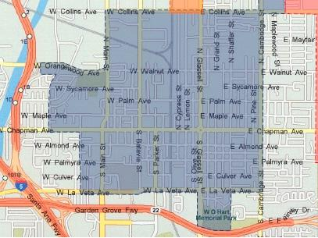

**Appendix III**

**Letter to City Attorney to request public records**

March 29, 2013

Tony Rackauckas

District Attorney Office Orange County

401 Civic Center Drive, Santa Ana, California 92701

RE: Public Records Act Request under California Public Records Act.

Dear Mr. Tony Rackauckas,

Pursuant to our rights under the California Public Records Act (Government Code Section 6250 et seq.), we request to obtain a copy of the following, which we understand to be held by your agency:

- A monthly summary of expenses dating back to 2003 which may be related to budgeting and spending for the implementation of the Gang Injunction zone located in Varrio Cypress (Glassell St. and Walnut Ave.) in the City of Orange, including investigations of people listed or potentially listen on the injunction, including prorated attorney’s salary and benefits, paralegal salaries and benefits, administrative overhead costs, court costs, copying costs, and any other kind of investigative, planning, or implementation costs of a legal nature.

- A summary of expenses of the City of Orange City Attorney’s Office dating back to 2003.

- Forms pertaining to the current Petition for Removal from Gang Injunction List for the Injunction zone located in Barrio Cypress (Glassell St. and Walnut Ave.) from the City of Orange.

-Statistical data on implementation and enforcement activities for Varrio Cypress (Glassell St. and Walnut Ave.) Gang Injunction, such as gang injunction-related arrests, court order, reported violations of the injunction, and crime statistics.

We are not seeking any documents covered by attorney-client privilege; by other statutory exemptions given in the Public Records Act; or on any personal files of personnel or person exempted. If you determine that some but not all of the information is exempt from disclosure, we ask that you redact it for the time being and make the rest available as requested.

We offer to cover any reasonable copying costs for the documents requires and if we can provide any clarification that will help expedite your attention to our request, please contact us at (xxx) xxx - xxxx

Thank you for your time and attention to this matter.

Sincerely,

Mia Russell

Mari Kawasaki

Monserrat Sepulveda

James Spady

**Appendix IV**

Senate Bill 296 - Assembly Committee on Public Security

<http://www.leginfo.ca.gov/pub/11-12/bill/sen/sb_0251-0300/sb_296_cfa_20110701_092530_asm_comm.html>

## California 186.20 California Street Terrorism Enforcement and Prevention Act, STEP Act

<http://www.streetgangs.com/laws/stepact.html>

San Francisco Opting Out Forms and Procedure

<http://www.sfcityattorney.org/index.aspx?page=20>

Los Angeles Opting Out Forms and Procedure

<http://atty.lacity.org/stellent/groups/electedofficials/@atty_contributor/documents/contributor_web_content/lacityp_007159.pdf>

Oakland Opting Out Forms and Procedure

<http://www.oaklandcityattorney.org/PDFS/People%20v.%20NSO_Opt%20Out%20attachment%20to%20proposed%20injunction.PDF>

**Appendix IV**

**Copy of letter from DA**

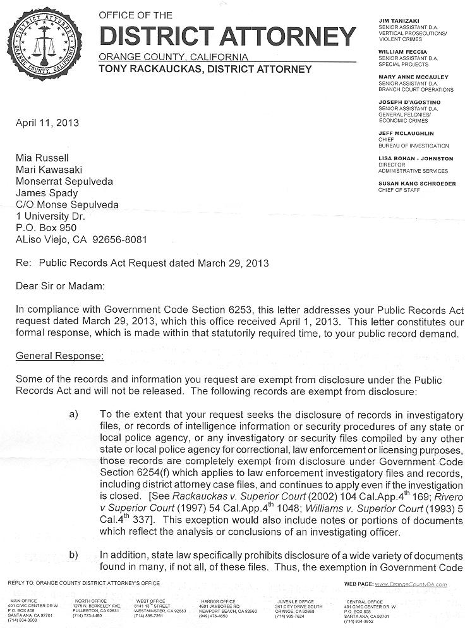

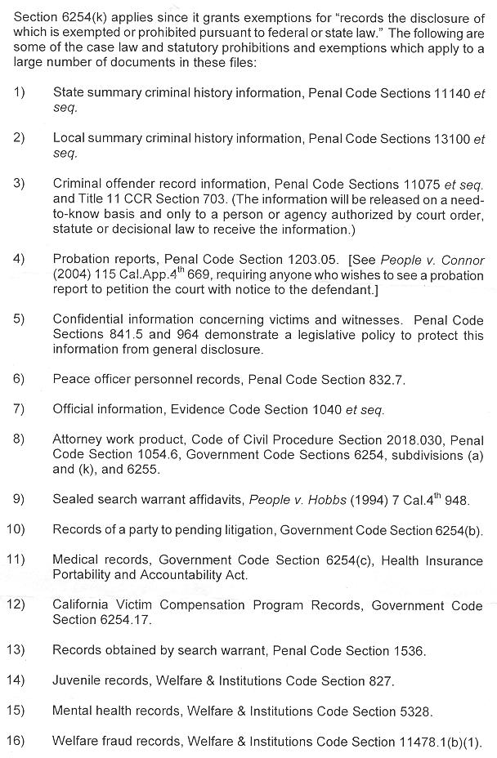

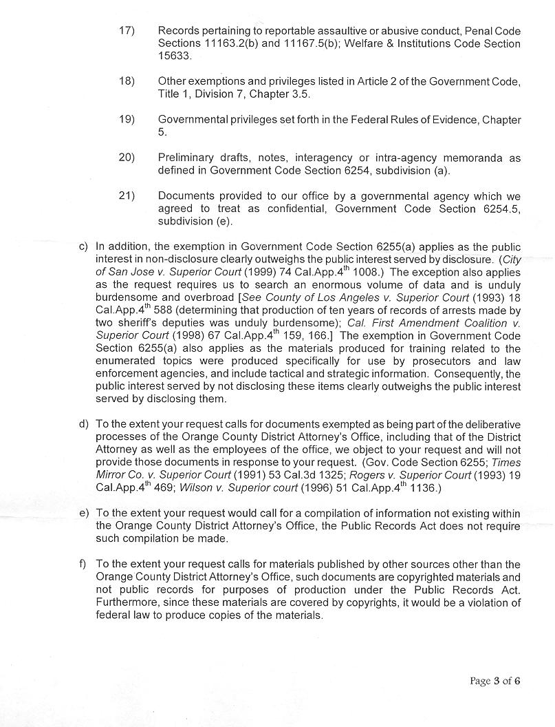

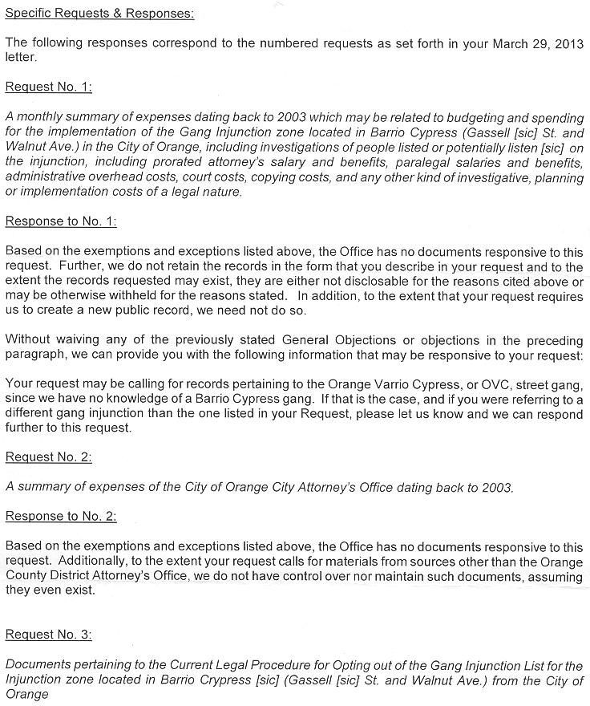

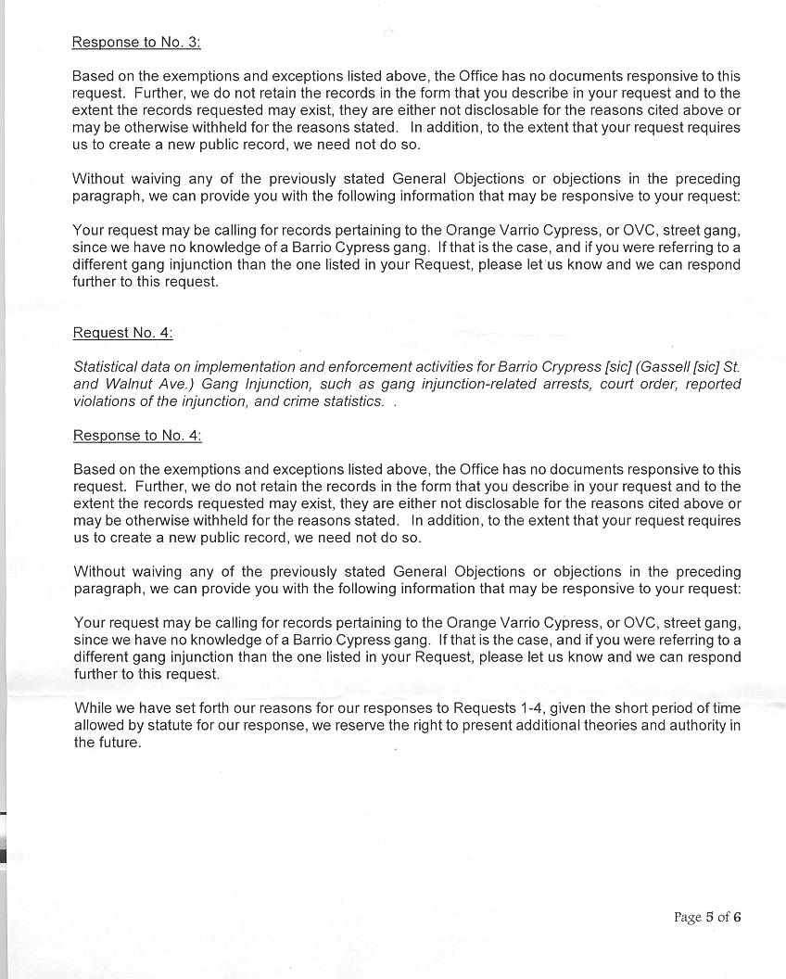

**Appendix VI**

**Orange County Petition for Removal - Informal Process (obtained directly from the DAs office)**

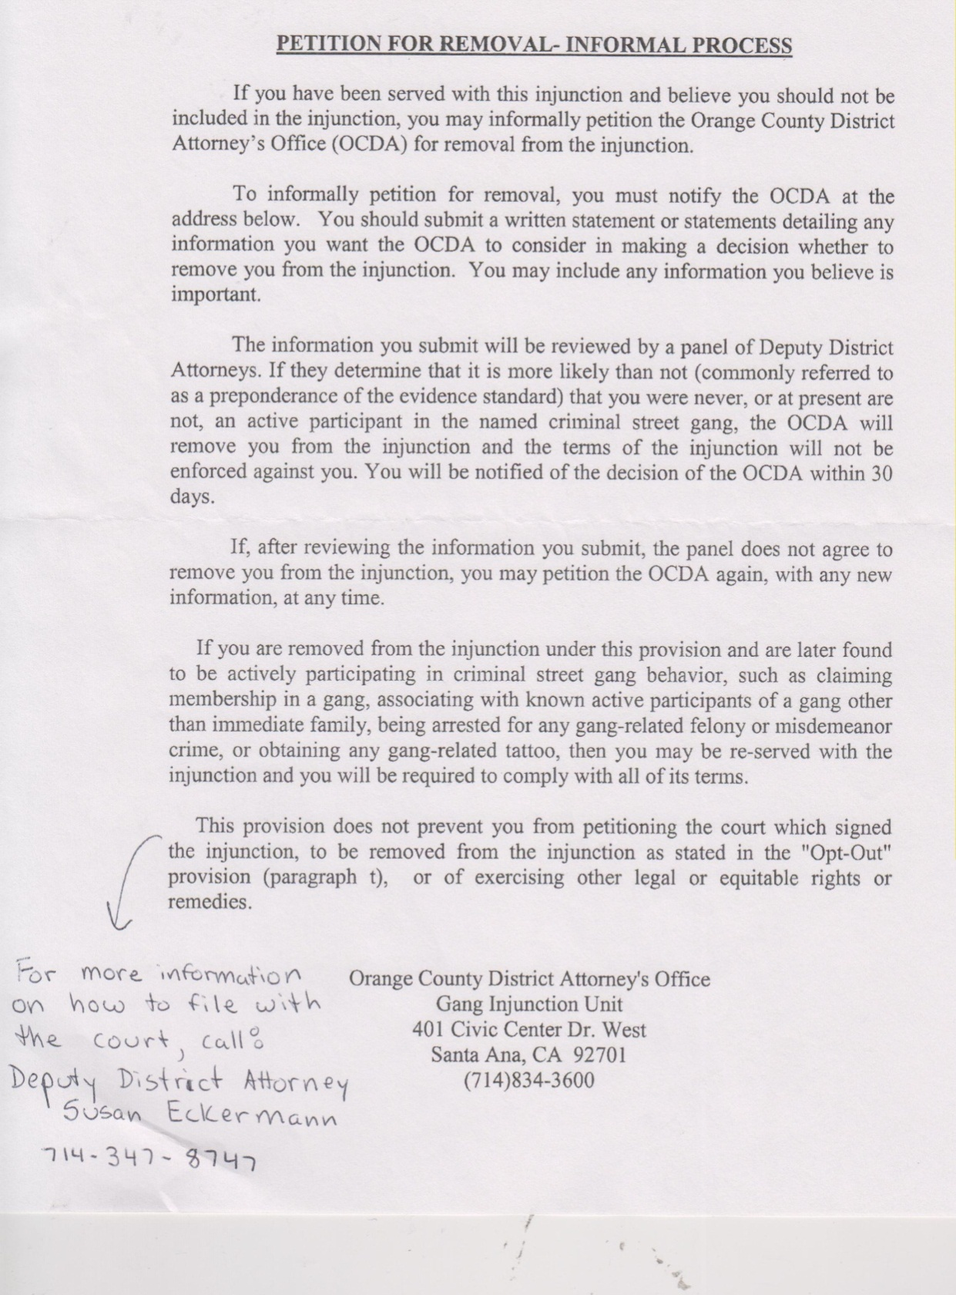

**Appendix VII**

**Current Formal Opt Out Form**





**Appendix VIII**

**Current Opt Out Letter – Formal and Informal Process**

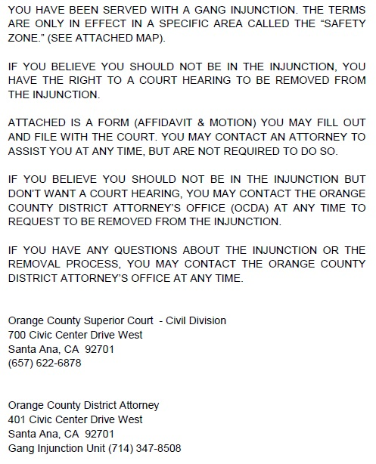

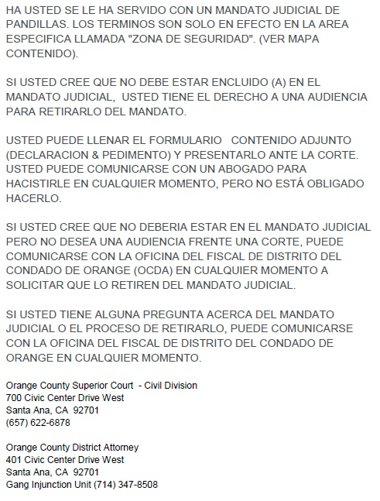

**Cited and Referenced Works**

ACLU.“ACLU/SC Sues Orange County D.A. for Illegally Placing Residents under Gang Injunction.”*aclu-sc.org.* American Civil Liberties Union of Southern California, 23, Sep. 2009. Web. 16 Apr. 2013.

<<http://www.aclu-sc.org/aclusc-sues-orange-county-d-a-for-illegally-placing-residents-under-gang-injunction/>>

ACLU.“Case Dismissed Against 62 people in Orange County Gang Injunction Case.” *aclu-sc.org.* American Civil Liberties Union of Southern California, 14, May 2009. Web. 16 Apr. 2013.  
<<http://www.aclu-sc.org/case-dismissed-against-62-people-in-orange-county-gang-injunction-case/>>

ACLU.“Judge finds O.C. District Attorney Cast Too Wide a Net in Gang Injunction.”*aclu-sc.org.* American Civil Liberties Union of Southern California, 7, May 2009. Web. 16 Apr. 2013.

<<http://www.aclu-sc.org/judge-finds-o-c-district-attorney-cast-too-wide-a-net-in-gang-injunction/>>

ACLU.“Major Victory in Orange County Gang Injunction Case.”*aclu-sc.org.* American Civil Liberties Union of Southern California, 11, May 2011. Web. 16 Apr. 2013.

<<http://www.aclu-sc.org/major-victory-in-orange-county-gang-injunction-case/>>

ACLU.“Vasquez v. Rackauckas.”*aclu-sc.org.* American Civil Liberties Union of Southern California, 31, May 2011. Web. 16 Apr. 2013. <<http://www.aclu-sc.org/vasquez/>>

Allan, Edward L. Civil Gang Abatement : The Effectiveness and Implications of Policing by Injunction (ebook: <http://site.ebrary.com/lib/soka/docDetail.action?docID=10159262>).

Altan, Daffodil J. “First Guy in the County to Get Himself off a Gang Injunction, Scott Free.”*Navelgazing*. OC Weekly, 24, July 2009. Web. 16 Apr. 2013. <<http://blogs.ocweekly.com/navelgazing/2009/07/gang_injunction_varrio_viejo_d.php>>

Altan, Daffodil J. “In an Unprecedented Move, DA Dismisses Bulk of Gang Injunction Cases in Orange.”*Navel Gazing*. OC Weekly, 15 May 2009. Web. 16 Apr. 2013. <<http://blogs.ocweekly.com/navelgazing/2009/05/judge_dismisses_more_than_half.php?print=true>>

Arellano, Gustavo. "Orange Gang Cops, Tony Rack Go After Emigdio Vasquez."*Navel Gazing*. OC Weekly, 16 Mar. 2009. Web. 11 Apr. 2013. <<http://blogs.ocweekly.com/navelgazing/2009/03/orange_gang_cops_tony_rack_go.php>>.

Atkinson, Scott E. The Outer Limits of gang injunctions. Vanderbilt Law Review, October 2006, Vol 59, Issue 5, 1693-1733.

Barajas, Frank P. An Invading Army: A Civil Gang Injunction in A Southern California Chicana/O Community. Latino Studies, Winter 2007, Vol. 5, No. 4, 393-417.

Caldwell, Beth. Criminalizing Day-to-Day Life: A Socio-Legal Critique of gang injunctions. American Journal of Criminal Law, 2010, Vol 37, Issue 3, 241-289.

Coker, Matt. “Orange County Gang Injunction Suffers Major Defeat: ACLU.” *Navel Gazing*. OC Weekly, 10 May 2011. Web. 16 Apr. 2013.  
<<http://blogs.ocweekly.com/navelgazing/2011/05/orange_county_gang_injunction.php>>

Crawford, Lindsay. No Way Out: An Analysis of Exit Processes for gang injunctions by Lindsay. California Law Review, 2009, 161 – 193.

"Cypress Street Barrio."*Cityoforange.org*. City of Orange, n.d. Web. 11 Apr. 2013. <<http://www.cityoforange.org/localhistory/CypressStreetBarrio/>>

## Fremon, Celeste. “[Dear Tony Rackauckas, It’s About That Constitutional Thingy, Says Fed Judge](http://witnessla.com/gangs/2011/admin/federal-judge-says-oc-da-violated-due-process-clause-with-gang-injunction/).” *witnessla.com.* Witness LA, 11, May 2011. Web. 16. Apr. 2013.

<<http://witnessla.com/gangs/2011/admin/federal-judge-says-oc-da-violated-due-process-clause-with-gang-injunction/>>

“Gang Injunctions.”*sfcityattorney.org.* Office of the City Attorney: City and County of San Francisco/City Attorney Dennis J. Herrera. Web. 25 Apr. 2013.

[<http://www.sfcityattorney.org/index.aspx?page=20](http://www.sfcityattorney.org/index.aspx?page=20)>

Gerber, Marisa. “Orange Gang-Injunction Case Headed to Federal Appellate Court.” *Navel Gazing*. OC Weekly, 23 June 2011. Web. 16 Apr. 2013.  
<<http://blogs.ocweekly.com/navelgazing/2011/06/orange_gang-injunction_case_he.php?print=true>>

Greene, Judith and Kevin Pranis.Gang Wars: The Failure of Enforcement Tactics and the Need for Effective Public Safety Strategies. A Justice Policy Institute Report, July 2007.

Grogger, Jeffrey. The Effects of Civil gang injunctions on Reported Violent Crime: Evidence From Los Angeles County. The Journal of Law and Economics, April 2002, Vol XLV, 69-90.

Hughes, Lorine A., James F. Short, Jr. Youth Gangs and Unions: Civil and Criminal Remedies. Trends in Organized Crime. Summer 2006, Vol 9, Issue 4, 43-59.

Jones, Alexander. Family Ties or Criminal Contacts: A case for Appointment of Counsel in Civil Gang Injunction Proceedings That Affect Family Relationships. Golden Gate University Law Review, 2008, Vol 39, Issue 1, 41-70.

Maxson, Cheryl, et al. “It’s getting crazy out there”: Can A Civil Gang Injunction Change a Community? Criminology and Public Policy Journal, 2005, Vol 4, No. 3, 577-606.

O’Deane, Matthew and Morreale, Stephen.Evaluation of the Effectiveness of Gang Injunctions in California. The Journal of Criminal Justice Research, 2011, Vol 2, No. 1, 1-32.

Stewart, Gary. Black Codes and Broken Windows: The Legacy of Racial Hegemony in Anti-Gang Civil Injunctions. The Yale Law Journal, May 1998, Vol. 107, No. 7, 2249-2279.

Wang, Cathy. Gang Injunctions Under Heat From Equal Protection: Selective Enforcement As a Way To Defeat Discrimination. Hastings Constitutional Law Quarterly, Winter 2008, Vol. 35, No. 2, 287-308.

Werdegar, Matthew Mickle. Enjoining the Constitution: The Use of Public Nuisance Abatement Injunctions against Urban Street Gangs. The Stanford Law Review, Jan. 1999, Vol. 51, No. 2, pp. 409-445.

Williams, Carol J. “Judge says Gang Injunction Subjects are Allowed Due Process.”*latimes.com.* Los Angeles Times, 11 May 2011. Web. 16 Apr. 2013.  
<<http://www.aclu-sc.org/judge-says-gang-injunction-subjects-are-owed-due-process/>>

1. This assertion, while made by Gil as well as several Chicanos Unidos members the authors consulted, could be researched in the future by analyzing city crime statistics in the Cypress Street Barrio and the El Modena areas.
2. The Orange County District Attorney’s office is located in 401 Civic Center Drive West, Santa Ana, CA 92701, phone number (714) 834-3600.